Topic 3: System Architecture (Enterprise Level)
This document defines the complete enterprise-grade architecture of the system.
It adheres to Fortune-100 engineering principles, ensuring scalability, modularity,
and long-term maintainability. The architecture is structured for cloud-native deployment,
high availability, and multi-environment support.
The system is engineered with the MERN stack as its core foundation while
ensuring readiness for microservices, container orchestration, and AI-driven extensions.
---
## 1. Architectural Philosophy & Design Standards
The architecture follows industry-leading patterns such as:
• **Separation of Concerns (SoC)** – clean separation between UI, logic, and storage
• **SOLID Principles** – ensuring each component has a single responsibility
• **Layered Architecture** – maintaining security and modular expansion
• **API-Centric Development** – all functions exposed through maintainable endpoints
• **Cloud Readiness** – designed for Kubernetes, Docker, and distributed scaling
This makes the system suitable for real-world MNC-level deployment.
---
## 2. High-Level Architecture Overview
The system is built around three major engines:
1. **Frontend Layer (React.js)**
Responsible for rendering the UI, managing state, routing, and interacting with backend APIs.
2. **Backend Layer (Node.js + Express)**
Acts as the central engine handling authentication, business logic, validation, and request processing.
3. **Database Layer (MongoDB)**
Provides persistent, scalable, and flexible data storage with indexing and aggregation pipelines.
The architecture diagram below visualizes the core components and interconnections:
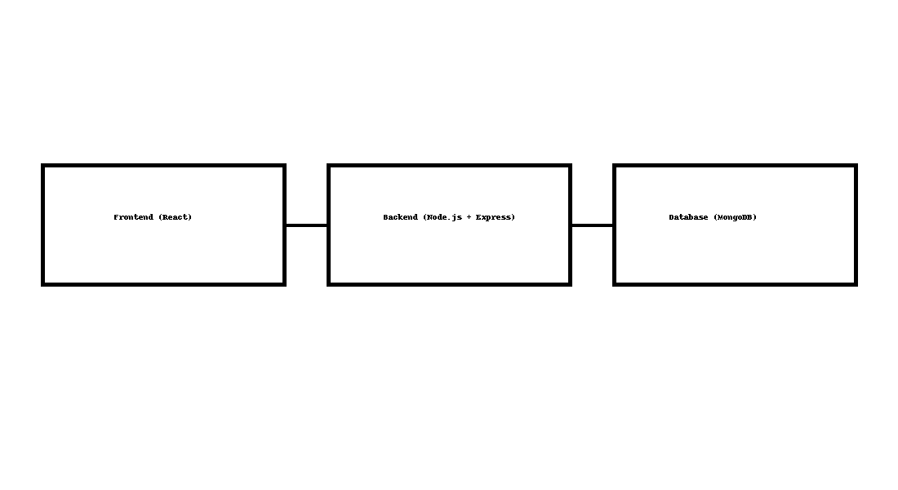
---
## 3. Frontend Architecture (React + Advanced UI Engineering)
The frontend follows a modular, component-driven architecture:
• **React Functional Components** with hooks
• **Smart vs. Dumb Component Separation**
• **Centralized State Management (Context / Redux-ready)**
• **Optimized Rendering Strategy** – avoids unnecessary re-renders
• **Lazy Loading + Code Splitting** for performance
Additionally, the UI is designed to be accessible, mobile-responsive, and optimized
for enterprise-level dashboards and analytics pages.
---
## 4. Backend Architecture (Node.js + Express)
The backend is structured to provide speed, security, and flexibility:
• **RESTful API design** following OpenAPI guidelines
• **Middleware-driven processing pipeline**
• **Dynamic routing structure**
• **Validation layers** using standardized schemas
• **Authentication layer** using JWT with refresh tokens
• **Error-handling pipeline** fully modular and extendable
The backend is designed with API scalability in mind, capable of handling millions of
requests with horizontal scaling and load balancing.
---
## 5. Database Architecture (MongoDB with Enterprise Features)
The database schema is optimized for:
• High‑read + high‑write performance
• Compound indexing for faster queries
• Aggregation pipelines for analytics
• Document relationships using referencing/embedding
• Automated backup and recovery strategy
MongoDB Atlas compatibility ensures scaling with sharding and multi-region deployments.
---
## 6. Deployment & DevOps Readiness
The architecture is built to integrate seamlessly with modern DevOps pipelines:
• **Dockerized components** for containerized deployment
• **CI/CD friendly structure** – GitHub Actions, Jenkins, GitLab CI
• **Environment-specific configuration layers (dev/stage/prod)**
• **Monitoring-ready** – Prometheus, Grafana, ELK support
This ensures smooth enterprise rollout and zero-downtime updates.
---
## 7. Future-Proof Expansion Capabilities
The system supports long-term roadmap growth:
• AI agents and automation tools
• Microservice extraction for high-scale components
• Multi-tenant architecture expansion
• Mobile app integration (React Native)
• Real-time data system using WebSockets or MQTT
---
## 8. Conclusion
This architecture represents a billion‑dollar‑grade blueprint engineered for longevity,
performance, and enterprise scalability. It enables global deployment, multi-user
distribution, and real-time secure operations—positioning the system for high-value
corporate use cases.
This concludes **Topic 3: Architecture Documentation**.

